COMP 7003

Assignment 2

User Guide

Aditya Singh Attri

A01276335

Oct 5th, 2024

# Purpose

This program captures and manually parses network packets using Scapy based on user-defined BPF filters. The program processes and displays relevant fields for ARP, IPv4, TCP, and UDP packets. It supports error handling for invalid interfaces and filters, and parses packet headers manually without using Scapy's built-in functions for field extraction.

# Obtaining

git clone <https://github.com/Aditya3650/COMP7003-Assignment2.git>  
(This is only the python code and the word docs, for correct submission directory and all the other docs, refer to the Learning Hub submission)

# Building

Only need python 3.10 or later

Install scapy using:

pip install scapy

# Running

You will need to open a terminal window on **Linux** or **Windows** (with the correct permissions to capture packets).

To run the program:

python scanner.py

This will start the packet capture based on the specified interface, packet filter, and number of packets to capture.

# Examples

To capture ARP packets:  
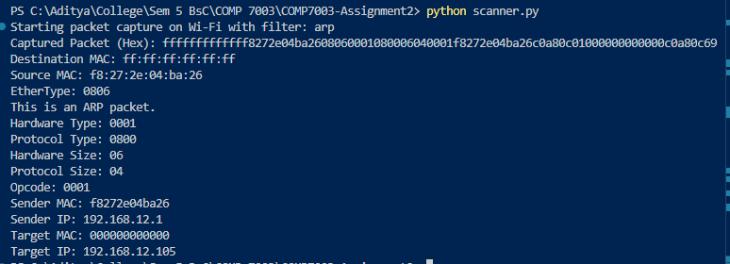

To capture IPv4 headers only:

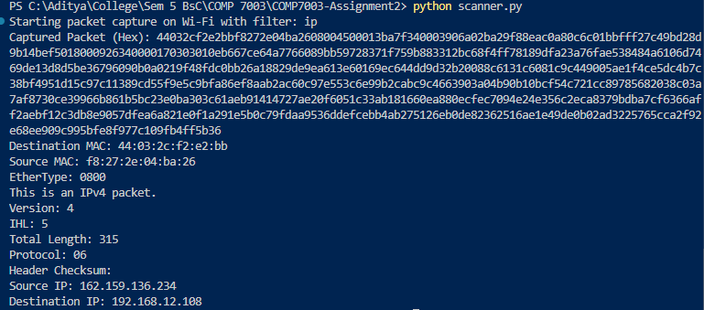

To capture TCP headers:

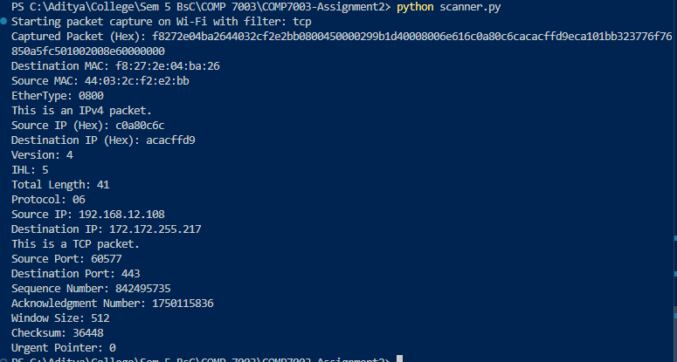

To capture UDP headers:

